KDP Optimization Checklist

BOOK INFORMATION
KEYWORD RESEARCH
Browse Categories, Keywords & KDP Categories
HELP FROM KDP SUPPORT
Adding More Than 10 Authors
Help with Browse Category Placement

BOOK INFORMATION

Title:

Subtitle:

Authors:

Book Description:

Price: 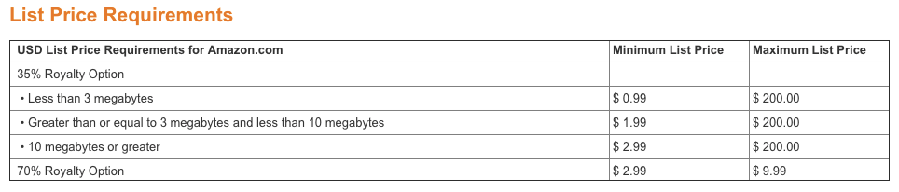
https://kdp.amazon.com/help/topic/A301WJ6XCJ8KW0

CATEGORY & KEYWORD RESEARCH

Browse Categories, Keywords & KDP Categories

- Browse Category:

Suggested Keyword:

KDP Category:

- Browse Category:

Suggested Keyword:

KDP Category:

HELP FROM KDP SUPPORT

Adding More Than 10 Authors
By default, the KDP account allows you to list 10 contributors and their titles. To include additional authors for books with multiple authors:
- Add the first 10 authors as contributors
- Publish the book
- Once published, Amazon assigns an ASIN number to the book
- Contact KDP Support
Option 1: Email KDP support - kdp-support@amazon.com (must be done from the email address associated with the KDP Account) with the request provided below.
Option 2: Login to the KDP account where the book is published.
- Select Help from top menu
- Select Book Details from side menu
- Select Changing Book Details from submenu
- Enter the request information provided below

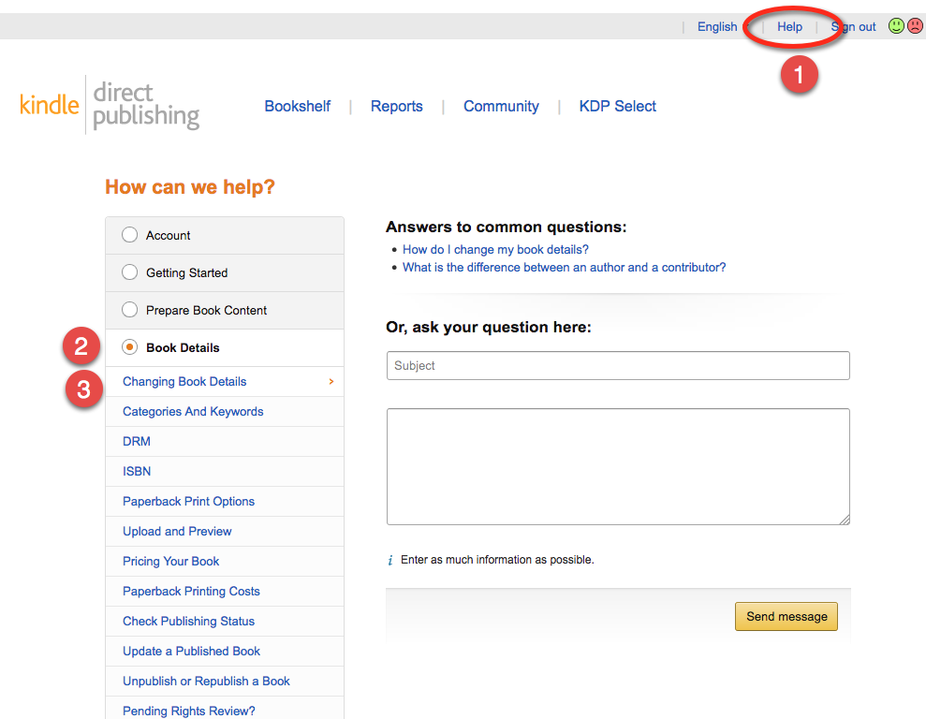
Subject: Request To Add Contributors
I would like to request to have the following Authors added to the title “[BOOK TITLE]” with ASIN: [asin#].
These are listed as First Name Last Name
Author Name
Author Name
Author Name
Author Name
Author Name

Help with Browse Category Placement
DO THIS ONLY AS A LAST RESORT - After making your best attempt to optimize the listing yourself
- Publish the book
- Once published, Amazon assigns an ASIN number to the book
Contact KDP Support
Option 1: Email KDP support - kdp-support@amazon.com (must be done from the email address associated with the KDP Account) with the request provided below.
Option 2: Login to the KDP account where the book is published.
- Select Help from top menu
- Select Book Details from side menu
- Select Changing Book Details from submenu
- Enter the request information provided below
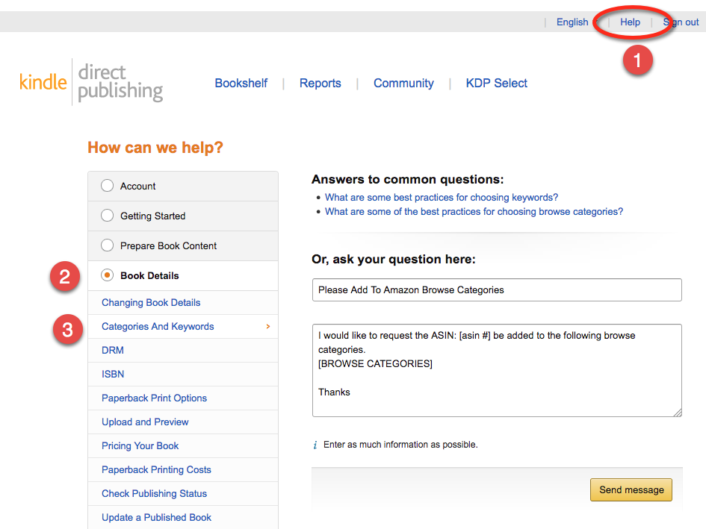

Subject: Please Add To Amazon Browse Categories
I would like to request the ASIN: [asin #] be added to the following browse categories.
[BROWSE CATEGORIES]
Thanks

