Best Seller Optimization Checklist

BOOK INFORMATION
Title:
Author:
ASIN:
Regular Price:
Campaign Price:
Date Published:
Target Campaign Date:

CAMPAIGN CHECKLIST
Pre-Campaign Checklist
- Categories & Keywords selected
- Confirm minimum pricing requirements
- KDP listing optimized & changes published
- Purchased copy from amazon.com store
- Confirm book is in Amazon ranking system
- Request KDP Support category placement
- Confirm book is in all targeted categories
- Schedule Best Seller Campaign

Day Before Campaign Checklist
- Check Category Competition
- Reduce Book Price
- Prime The Pump

Campaign Day Checklist
- Check Category Competition
- Post Campaign Links in FB Group
- Check Hourly Ranking changes
- Get Screenshots
- Close out campaign

CATEGORY & KEYWORD SELECTION

TOP TARGETED AMAZON CATEGORIES
- Amazon Category:
Targeted Ranking:
Estimated Sales Needed:
Suggested Keyword:
KDP / BISAC Category:

- Amazon Category:
Targeted Ranking:
Estimated Sales Needed:
Suggested Keyword:
KDP / BISAC Category:

ADDITIONAL / BACKUP CATEGORIES
- Amazon Category:
Targeted Ranking:
Estimated Sales Needed:
Suggested Keyword:

- Amazon Category:
Targeted Ranking:
Estimated Sales Needed:
Suggested Keyword:

- Amazon Category:
Targeted Ranking:
Estimated Sales Needed:
Suggested Keyword:

- Amazon Category:
Targeted Ranking:
Estimated Sales Needed:
Suggested Keyword:

- Amazon Category:
Targeted Ranking:
Estimated Sales Needed:
Suggested Keyword:

CONFIRM MINUMUM PRICING
Minimum Kindle pricing is determined by the royalty option you select and the size of your manuscript file. For the best results your book should be priced at .99 for campaign day. If you are unable to set the price at .99 is usually due to the royalty option or file size of your book.

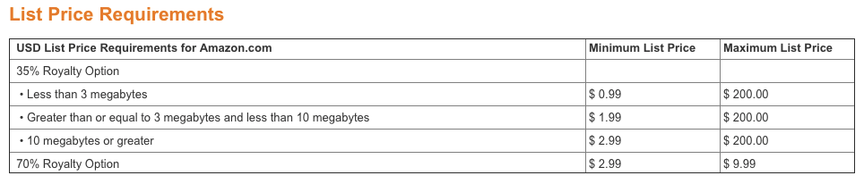
For more information on KDP Pricing visit https://kdp.amazon.com/help/topic/A301WJ6XCJ8KW0

The most common reason a file will exceed the 3 megabyte maximum for a .99 price is the amount and size of images included.

If your book contains BMP or PNG formatted images, you can decrease the size of your file by saving your images in JPEG format and then reinserting them. Here's how:
- Open the file in your image editing application (e.g. Adobe Photoshop®, Snagit)
- Select "Save As"
- Choose JPEG or JPG as the file type

Requesting Category Placement From KDP Support
Your kindle can be listed in a maximum of 10 Amazon Categories. Once you’ve optimized and published your book you can request KDP Support to place your title in the additional/backup Amazon Categories you selected.

You must publish the book before requesting category placement from KDP Support.
Once published, you will need the ASIN assigned to your book to provide to KDP Support along with your request for category placement.

You can get the ASIN from your KDP Bookshelf

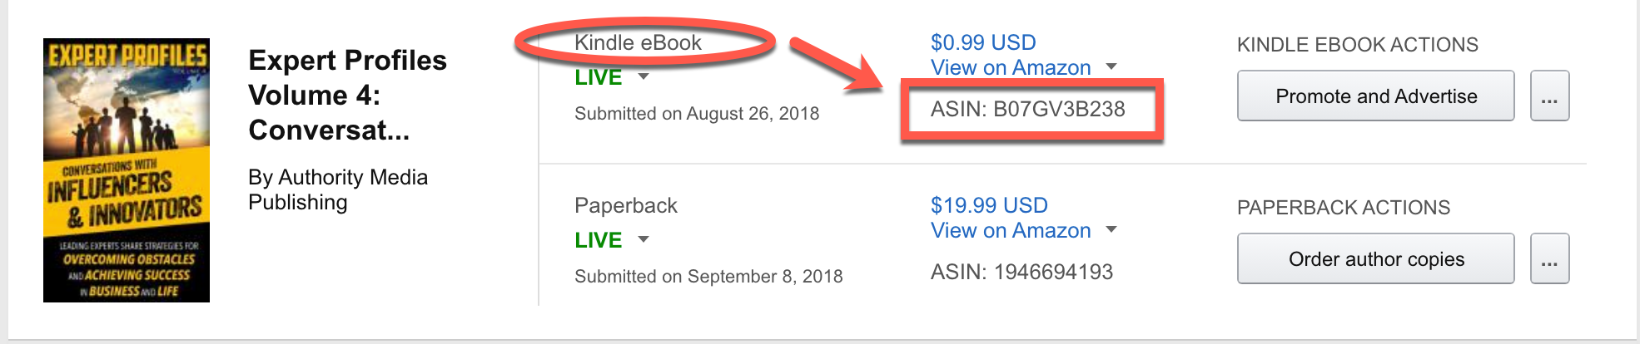

OR from the Product details section of the book listing on Amazon

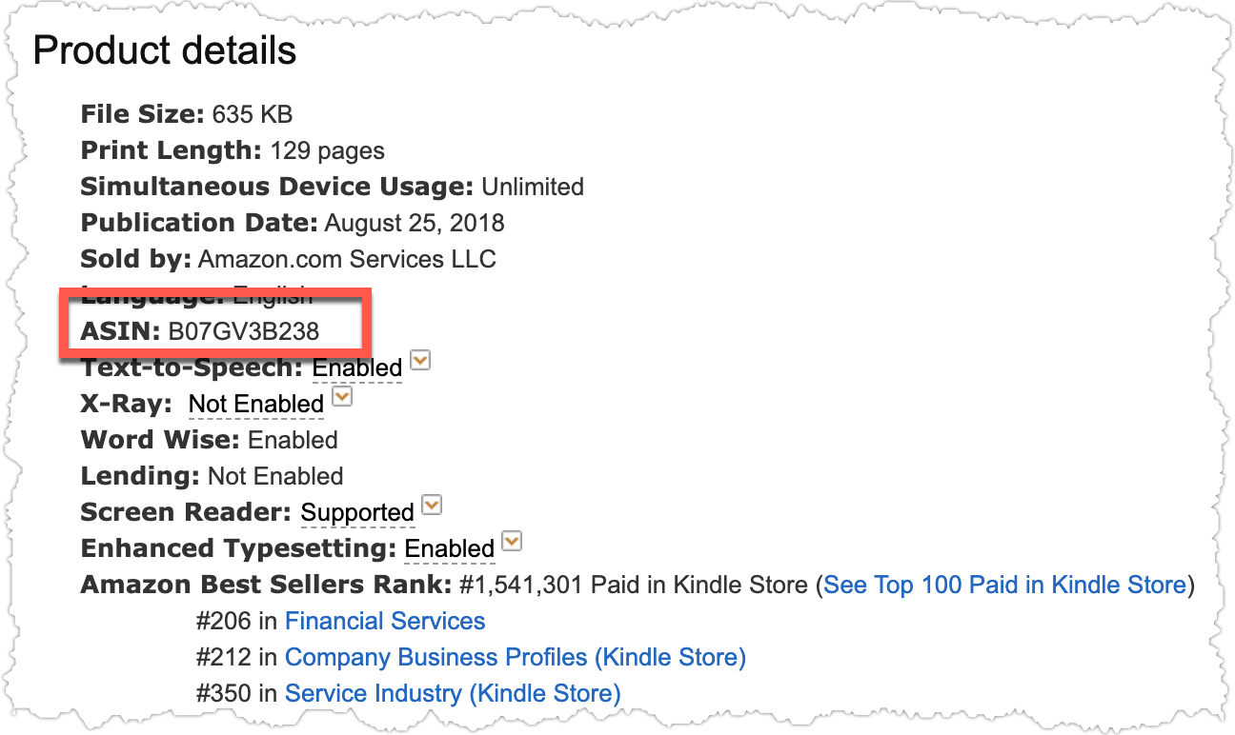

Once your book is published and you have the ASIN you can contact KDP Support to request category placement

Option 1: Email KDP support - kdp-support@amazon.com (must be done from the email address associated with the KDP Account) with the request provided below.
Option 2: Login to the KDP account where the book is published.
- Select Help from top menu
- Select Book Details from side menu
- Select Changing Book Details from submenu
- Enter the request information provided below
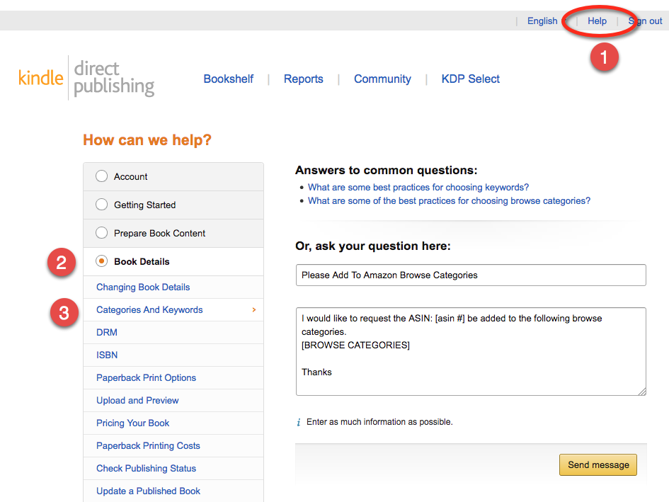

Subject: Please Add To Amazon Browse Categories
I would like to request the ASIN: [asin #] be added to the following browse categories.
[INSTERT BROWSE CATEGORIES]
Example:
Kindle eBooks ‹ Business & Money / Marketing & Sales Marketing / Marketing / Direct
Kindle eBooks ‹ Business & Money ‹ Marketing & Sales Marketing / Marketing / Global
Thanks

Adding More Than 10 Authors
By default, the KDP account allows you to list 10 contributors to your Kindle eBook. To include additional authors for Kindle eBooks with multiple authors:
- Add the first 10 authors as contributors
- Publish the book
- Once published, Amazon assigns an ASIN number to the book
- Contact KDP Support
Option 1: Email KDP support - kdp-support@amazon.com (must be done from the email address associated with the KDP Account) with the request provided below.
Option 2: Login to the KDP account where the book is published.
- Select Help from top menu
- Select Book Details from side menu
- Select Changing Book Details from submenu
- Enter the request information provided below

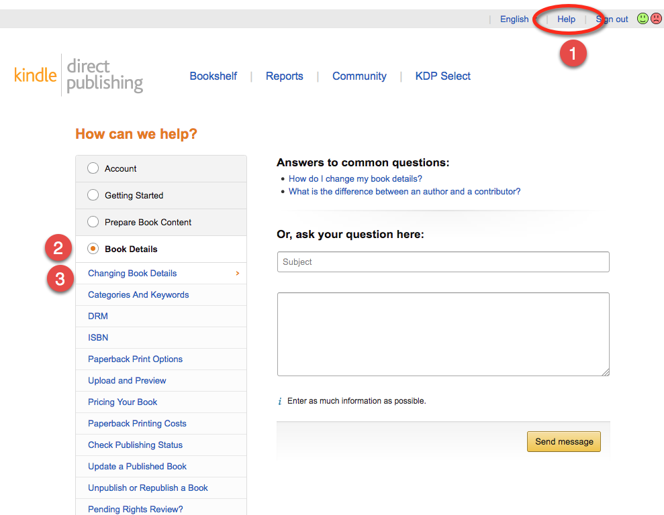
Subject: Request To Add Contributors
I would like to request to have the following Authors added to the title “[BOOK TITLE]” with ASIN: [asin#].
These are listed as First Name Last Name
Author Name
Author Name
Author Name
Author Name
Author Name

