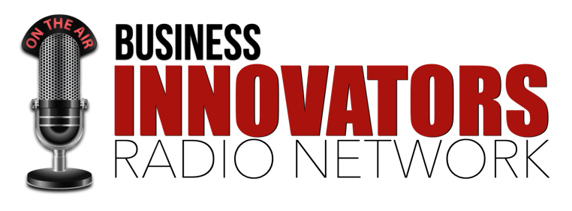
Guest Information

Let me start by welcoming you as a guest on Business Innovators Radio. I’m looking forward to our interview and know that you are going to provide some great content for our listeners.

Interview Framework
The Business Innovators Radio interview framework is designed to position you as a “Subject Matter Expert” in your field.

My role as the host is to set the stage by asking questions from the voice of your “Perfect Prospect”. This will allow you to focus on being the Educator and Advocate for the success of the people who most need the information you have to share.

To create the best content, we will discuss the following:

WHO - Description of the customers/clients you help.

WHAT – The outcome that you help them accomplish.

WHY – Why they want/need to achieve this outcome and the consequences if they don’t.

OBSTACLES – The most common Fears, Misconceptions, Mistakes, Unknown Pitfalls around achieving this outcome.

HOW – How you help them overcome the obstacles to successfully achieve this outcome.

BACKSTORY - What inspired you to do what you do and help the people you serve?

Scheduling Your Interview
You can schedule your interview by visiting (YOUR SCHEDULING LINK)

Interview time slots are available Tuesday – Thursday between 12pm – 4pm eastern time. If you need to book your interview outside of these time slots please send an email to (YOUR EMAIL)

This interview will be audio only. We’ll spend a few minutes chatting about your introduction and subject matter before we start recording. The recorded interview portion will be 25 to 30 minutes. Please allow 45 – 60 minutes for our call.

Calling in For Your Interview
You will have the option of calling in on Zoom or by phone. A Zoom link and Call-In information will be sent to you when you schedule your interview.

IMPORTANT – For Best Quality Audio When Calling in For Your Interview

If calling by phone, please do not use hands free/speaker phone options. A landline is recommended; however, a strong cell phone signal should be fine as well.

If calling on Zoom, please use headphones to avoid echo during the interview. A wired network connection is recommended, however strong Wi-Fi connectivity will work fine.

Information Needed From You
To get the most out of our interview please provide the following items.

Photo – Head shot or promotional image that we can use for your episode.

About You – Please provide links to your website about me page, bio information and/or media kit that will help me learn a little more about you before our interview.

Social Media Links – Please provide links to any Social Media profiles you would like included on your show page.

Interview Topic - Please provide your interview topic and any products or services you would like to mention during our interview. (If available, provide a link to a prior interview that you would like to model).

Please email this info to (YOUR EMAIL) with the subject Show Info.

